**Geography 150 Lab 4: Adiabatic processes and moisture in the atmosphere**

**Name : Tracy Harvey**

**Date: April 29, 2024**

Assume that a parcel or mass of air is forced up and rises over a ***4000 meter (13,100 feet) high mountain*** (shown below). The height of this mountain would be intermediate between Mt. Olympus (elevation: 7980 feet or 2432 meters) in the Olympic mountains and Mt. Rainier (elevation: 14,410 feet or 4392 meters) in the Cascade mountains. This process, called the orographic effect or orographic lifting, is characteristic of our region as air moves inland off the ocean and encounters mountain ranges.

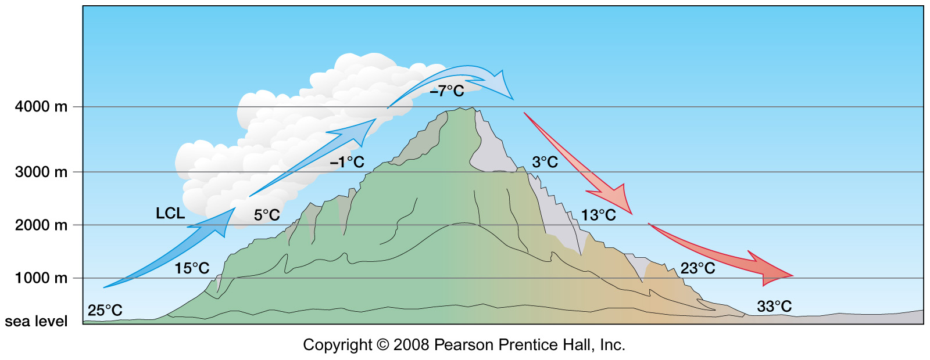

The ***initial temperature of the parcel of air at sea level is 25 degrees Celsius*** or 77 degrees Fahrenheit. The ***final temperature of the air at sea level is 33 degrees Celsius*** or 91.4 degrees Fahrenheit. These temperatures might be quite typical of a summer day here in western Washington and in eastern Washington east of the Cascade Range.

The ***lifting condensation level (LCL) of the parcel is 2000 meters*** (6550 feet). The ***DAR or dry adiabatic rate is 10 degrees C/1000 meters*** or 5.5 degrees F/1000 feet. The ***SAR or saturated adiabatic rate is 6 degrees C/1000 meters*** or 3.3 degrees F/1000 feet. Assume that condensation begins at 100% relative humidity and no evaporation adds water to the parcel as it descends the lee hand side of the mountain.

1. Why is the parcel of air warmer at sea level on the lee side (to right) than it was at sea level on the windward side (to left)? What is the source of the heat energy?

While the air is rising on the windward side it undergoes adiabatic cooling. Basically it cools by 10 degrees per 1000 ft resulting in condensation. On the leeward side the air undergoes adiabatic warming from compression as I understand it. So as the air descends to sea level it heats up resulting in warmer temps. As I understand it the source of this heat is the latent heat that is released during the condensation phase on the windward side.

1. On the windward side of the mountain, is the relative humidity of the parcel increasing or decreasing as it rises from sea level to 2000 meters (6550 feet)? Why?

As the parcel rises from sea level to 2000 meters the humidity of the parcel is increasing. The reason is that as it rises it approaches the point where the air cools to its dew point and then condensation happens which is where the air has a 100% humidity level.

1. On the lee side of the mountain, is the relative humidity of the parcel increasing or decreasing as it descends from 4000 meters (13,100 feet) to sea level? Why?

As the parcel descends to sea level on the lee side of the mountain, the air warms up the airs capacity to hold moisture increases so as the parcel descends farther toward sea level the parcels humidity actually decreases.

Consider the chart of Saturation mixing ratios or ***water vapor capacity*** (below) and interpolate from the chart as needed. The red line is the maximum amount of water vapor that can be in the air at the given temperatures. As temperature of the air increases (to right) the water vapor capacity of the air increases. Assume that condensation begins at 100% relative humidity and that no moisture is added by evaporation as the parcel descends.

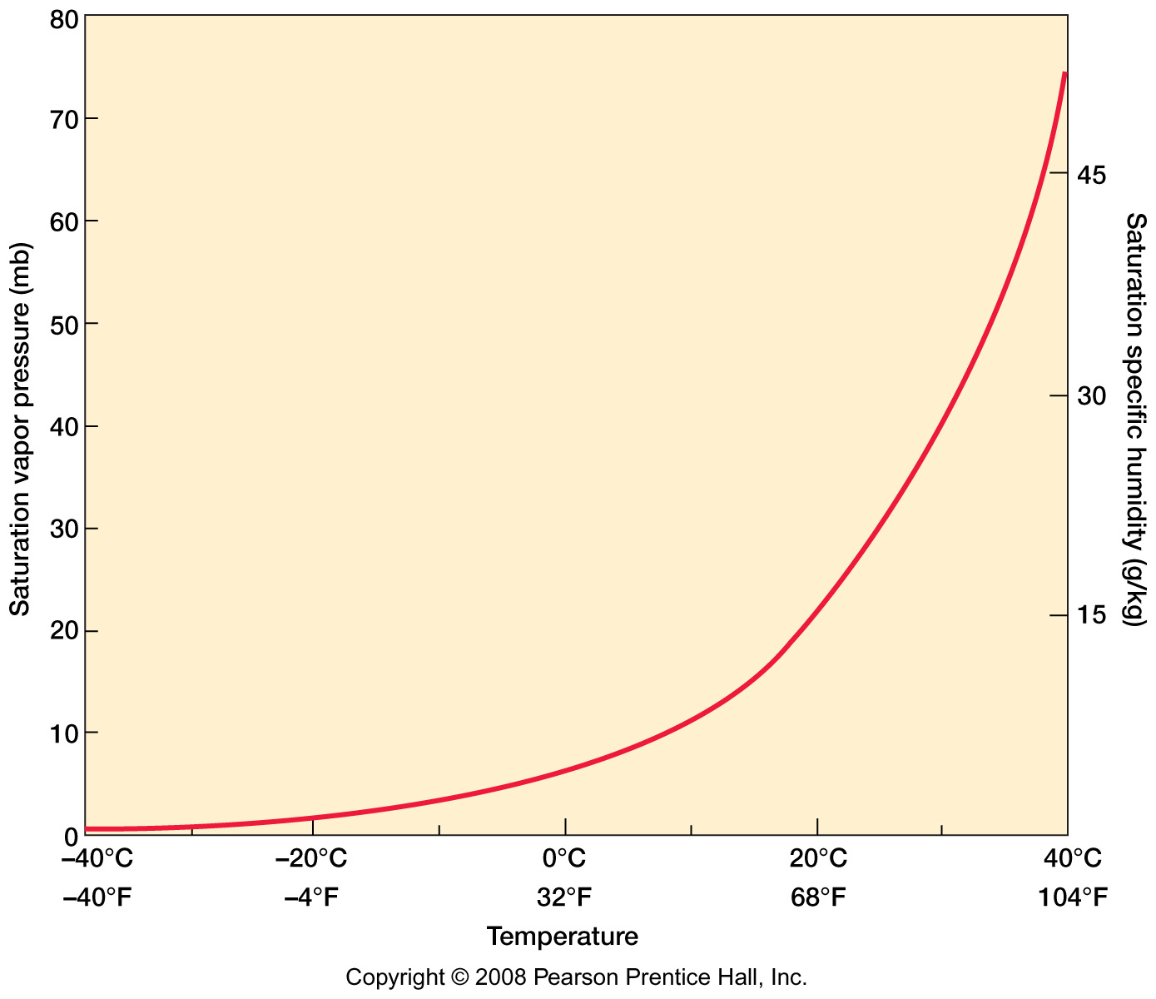

1. On the windward side of the mountain, should the relative humidity of the parcel change as it rises from 2000 meters (6550 feet) to 4000 meters (13,100 feet)? Why?

No, relative humidity of the parcel would not change as it rises from 2000 meters to 4000 meters. As the parcel rises on the windward side its temperature decreases due to adiabatic cooling and condensation begins because the humidity is at 100% therefore the relative humidity of the air would remain 100% as it continued to rise.

1. As the air rises up the windward side of the mountain:What is the capacity (saturation mixing ratio) of the rising air at 2000 meters in g/kg?What is the capacity of the air at 4000 meters in g/kg?

As I am understanding the saturation mixing ratio you need a temperature in order to calculate it and no temperature is given only elevation. I am basing my answer on a combination of the chart for questions 1 – 3 for the temperature and the chart for this section. If I am understanding this incorrectly please correct me.

Assuming that at 2000 meters the temp is 5 degrees Celsius the capacity is right around 7g/kg

Assuming that at 4000 meters the temp is -7 degrees Celsius the capacity is right around 4g/kg

1. What is the capacity of the air after it has descended back down to sea level on the lee side of the mountain in g/kg?

Again I am assuming temperatures of the air

Assuming that at sea level the temp is around 33 degrees Celsius the capacity would be around 18 – 20 g/kg

1. Assuming that no water vapor is added as the parcel descends on the lee side of the mountain to sea level, is the water vapor content (the mixing ratio) of the parcel higher or lower than before it began to rise over the mountain? Why?

As no water vapor is added as the parcel descends the vapor content would stay the same as the air descends it would warm up increasing its capacity to hold moisture decreasing the humidity resulting in a lower mixing ratio than before it began to rise over the mountain.

1. What is the lifting condensation level (LCL) of the parcel after it has descended to sea level on the lee side of the mountain?

On the lee side of the mountain the Lifting Condensation Level (LCL) would be higher than on the windward side due the air temperature being higher but to do an exact calculation you would need to know the temperature at sea level on the lee side of the mountain.